1.

DFA M = ($Q,Σ{,q}_{0,}δ,F$) where

Q= $\{ q0 , q1 , q2 , q3 \}$

$Σ$ = { 0 , 1 }

F= { q1 , q3 }

The function $δ$ is given by

|  |  |  |
| --- | --- | --- |
| $$δ$$ | 0 | 1 |
| q0 | q1 | q3 |
| q1 | q1 | q2 |
| q2 | q2 | q2 |
| q3 | q1 | q3 |

2.

a).

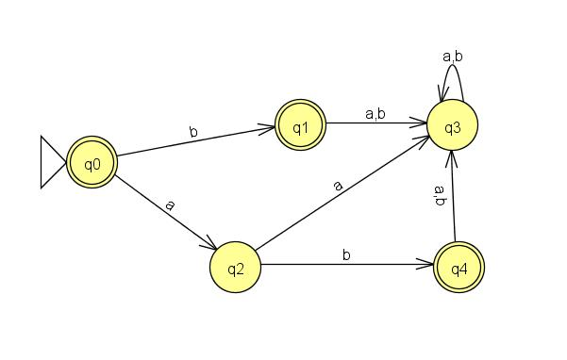

b)

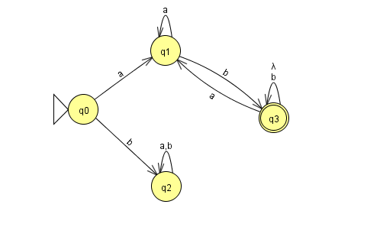

c)

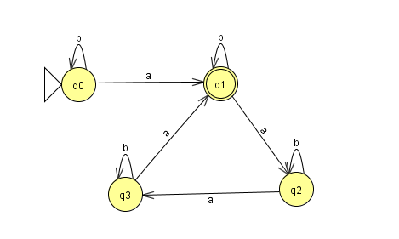

d)

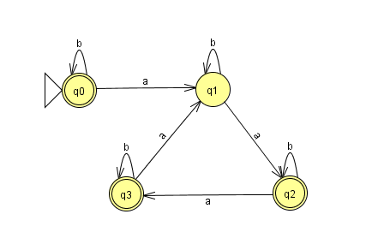

3.

Because show L is regular language by DFA,

W is binary representation of an odd integer, so the end must be 1.

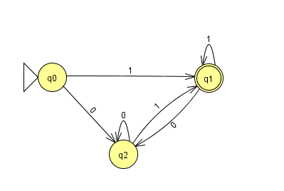

4.

a)

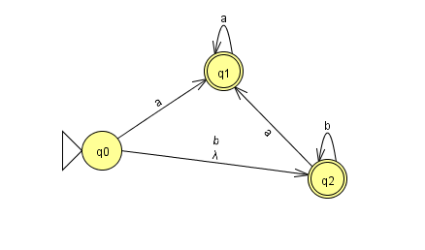

b)

